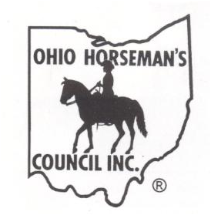
The North West Region
Ohio Horseman’s Council
State Ride
on
September 22, 23, 24, 2023 at Van Buren State Park!

Friday Starts at 1 PM
Rock/scavenger hunt! Burgers/hot dogs meal! Music at campfire! Silent auction! Night ride!
Saturday
Obstacle course! Trick or Treat! 50/50! Scavenger Hunt! Potluck Dinner BBQ ! Live auction!
Sunday
Light breakfast provided! Cowboy Church at 10 AM!

For more information contact Al Sidell
at 419-680-2036 or sidellandco@yahoo.com

Make your Camping Reservations early at RESERVEOHIO.COM or 866-644-6727.

*If the Equestrian Sites are full we have permission to camp on the outside sites of the Family Campground Area.
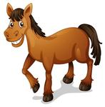
If unable to make reservations, call AL!

